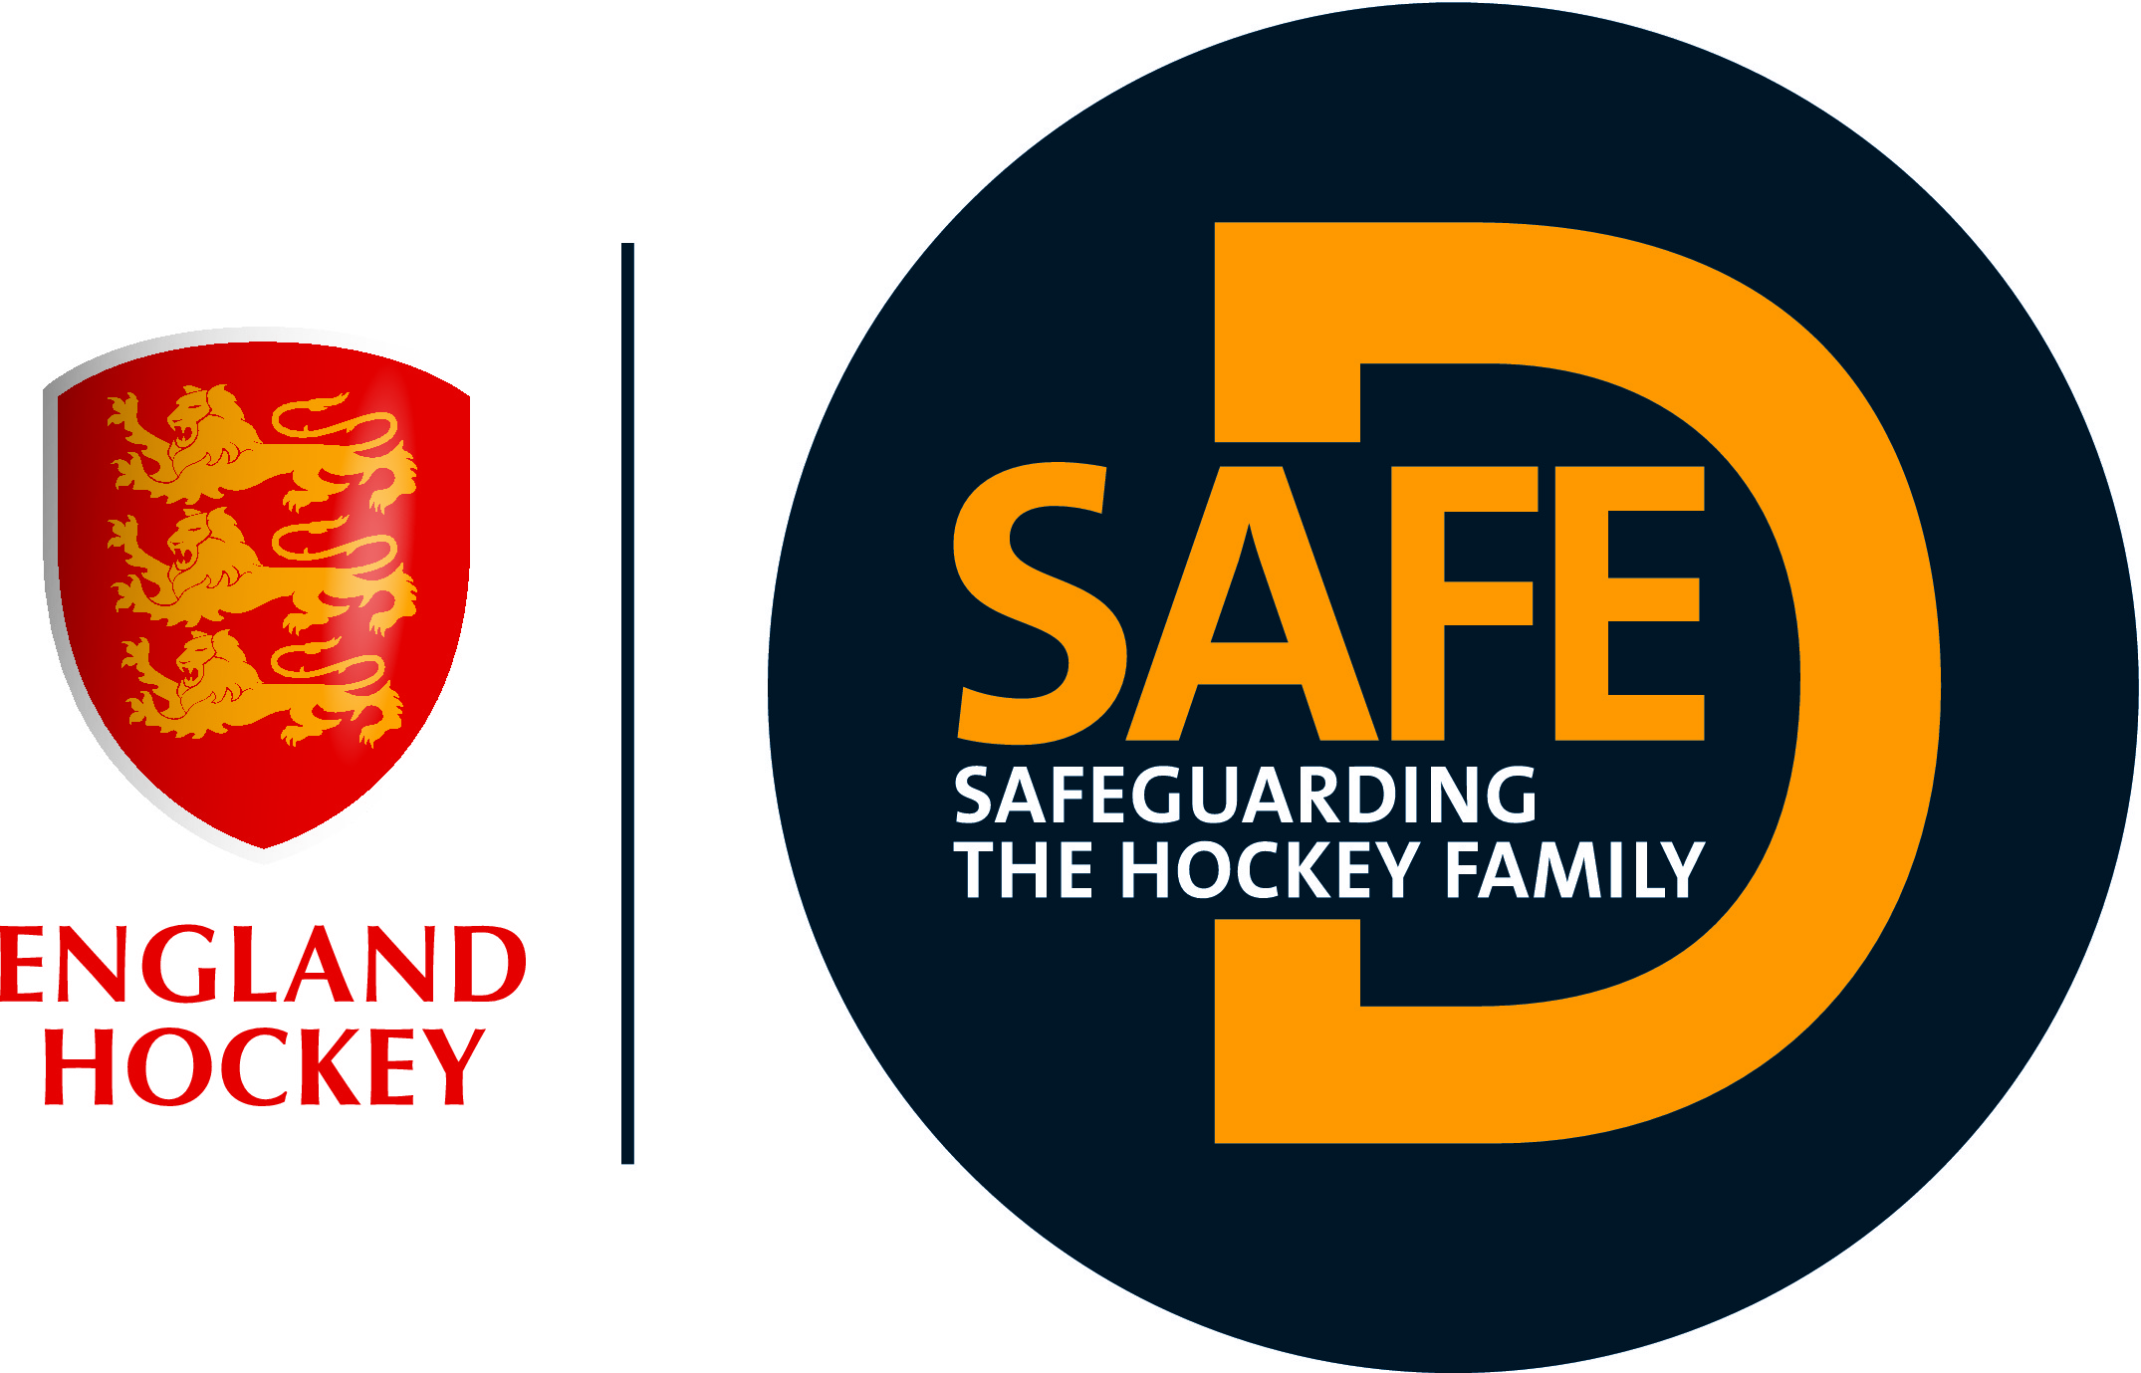

**REPLACE WITH CLUB LOGO**

**Positive Imagery**

**(INSERT CLUB NAME) promotes positive imagery and we ask you as parents, family, carers and supporters to help us achieve this.**

Our registered photographers will be taking images to use in our official publications; they can be identified by their ‘Official Photographer’ bibs (and big cameras!).

For those on the sidelines wishing to take images of the action, we ask you to:

* Consider where you post your images
* If sharing on social media, we strongly recommend that u18’s cannot be identified by name.
* You may be taking/sharing images of other people’s children so again be wary of sharing these images.

If you have a concern, please contact: INSERT WELFARE OFFICER DETAILS

England Hockey’s *Photography Guidance* can be found at www.englandhockey.co.uk/safe